Assignment 1
Hermmy Wang – 704978214
CS 130 Discussion 1B

Q1: Probing Patterns
- Adapter pattern.
- Strategy pattern.
- Observer pattern.
- Singleton pattern.
- Mediator pattern.

Q2: Diagramming DoorDart

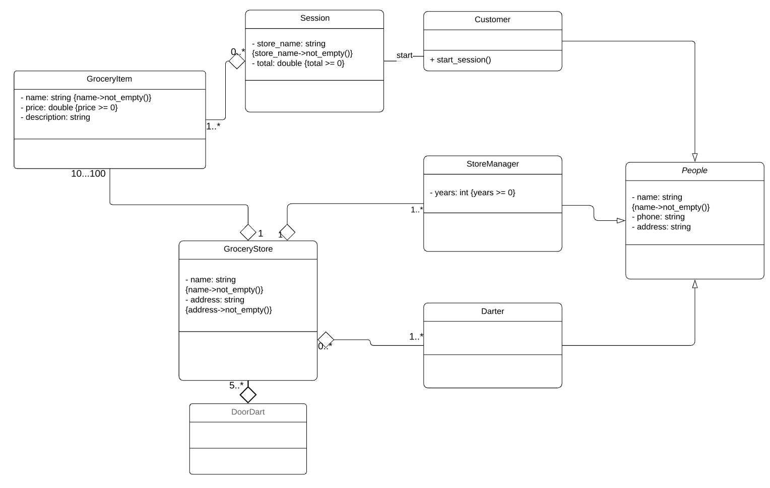

Constraints added to my UML class diagram:
- Any name string cannot be empty.
- Price of grocery items must be positive.
- Total price is a customer’s session cannot be negative.
- Years of experience cannot be negative.
- Grocery store must have a valid address.

Q3: Let’s Log

public class Logger {
private volatile static Logger uniqueInstance;
private Logger() {}
public static synchronized Logger getLogger() {
if (uniqueInstance == null) {
// If there does not exist a resource instance,
// then the program should run into a synchronized block.
synchronized(Logger.class) {
// Once it goes into the synchronized block,
// it should check if it is still null.
if (uniqueInstance == null) {
// If the resource is null, we create such an instance.
uniqueInstance = new Logger();
}
}
}
return Logger;
}
}

Q4: Judging JHotDraw

a (1).
AbstractColorSlidersModel, DefaultColorSliderModel, PaletteColorSliderModel
a (2).
addChangeListerner corresponds to registerObserver().
stateChanged corresponds to update().

b.
The following four lines of code demonstrate the use of a drawing strategy:
drawing.removeAllChildren();
drawing.set(CANVAS_WIDTH, figure.getBounds().width);
drawing.set(CANVAS_HEIGHT, figure.getBounds().height);
drawing.basicAdd(figure);

c.
Strategy pattern defines a family of algorithms which are encapsulating each other and makes the algorithms interchangeable at runtime. Strategy lets the algorithm vary independently from the clients that use them. Therefore, from the perspective of information hiding principle, strategy pattern hides the secrets of the algorithms from the clients who use these algorithms. In the previous example, the algorithms, such as set() and basicAdd() in Drawing class, can change independently without affecting the clients, ImageInputFormat.

d (1).
DefaultDrawingView implements DrawingView
d (2).
Register a new DrawingView object at line 122 of DrawingEditor.java:
void add(DrawingView view);
d (3).
Remove an existing DrawingView object at line 129 of DrawingEditor.java:
void remove(DrawingView view);

Q5: Sequence Sketching

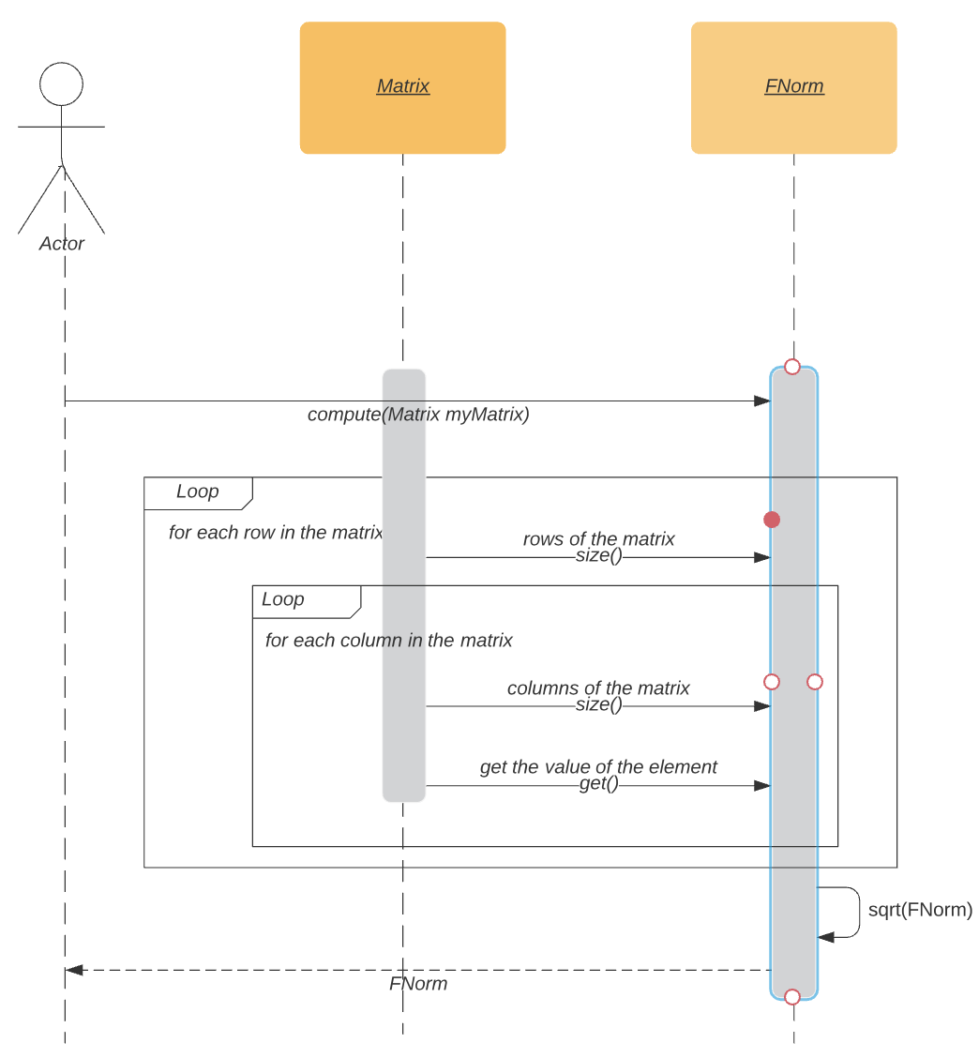

Q6: Problematic Python Piece

(a). This style of code leads to problems when a new method of computing distance is added or removed. The class DistanceFinder will have to change, too. Also, there are parts in DistanceFinder that should remain same even when new methods of computing distance are added; we should separate the parts that vary and that stay constant.

(b).
from abc import ABC, abstractmethod
class Vector:
... # unchanged

class DistanceFactory(ABC): # abstract class
def square_rooted(x):
return round(sqrt(sum[a*a for a in x])), 3)

@abstractmethod
def compute(self, v1, v2): # abstract method compute()
pass

class EuclideanFactory(DistanceFactory): # implement the abstract class
def compute(self, v1, v2):
return sqrt(sum(pow(a-b,2) for a,b in zip(v1.value, v2.value)))

class ManhattanFactory(DistanceFactory): # implement the abstract class
def compute(self, v1, v2):
return sum(abs(a-b) for a,b in zip(v1.value, v2.value))

class CosineFactory(DistanceFactory): # implement the abstract class
def compute(self, v1, v2):
numerator = sum(a*b for a,b in zip(v1.value, v2.value))
denominator = square_rooted(v1.value)*self.square_rooted(v2.value)
return round(numerator/float(denominator),3)

class DistanceFinder:
def __init__(self, factory):
self.factory = factory # pass in a concrete instance of DistanceFactory

def find_distance(self, v1, v2, type):
distance = factory.compute(v1, v2, type)
return distance

(c). I use abstract factory pattern. In this pattern, we can move the distance computation out of DistanceFinder class, so modifying the computations will not affect DistanceFinder class itself. I move the distance computation to another abstract class called DistanceFactory. The concrete implementations of DistanceFactory are different methods of computing distances. In each concrete implementation, the class implements the abstract method compute() in their own way. Now, DistanceFinder no longer needs to take care of the actual computation of the distance.
Q7: Knowing KWIC

I. False. Information hiding principle is not about having private and public attributes in a class. Instead, the principle should hide secrets, or the content of the data structure, from the users. The public getter method here still requires the user to know the content inside the 2D array, so it is not following the information hiding principle.

II. False. Using a static call does not necessarily violates the information hiding principle.

III. True. Since the type of data structure in Input is changed, the public getter method’s return type also changes, too. This leads to modification in all classes that have access to this data, including CircularShift, Alhabetizing, and Output.

IV. True. A violation of information hiding principle is that changing internal data layout of one class affects other classes that use it. Information hiding principle requires the class to hide its secrets from its clients. Changing internal data structure should not have any effects on its clients.

